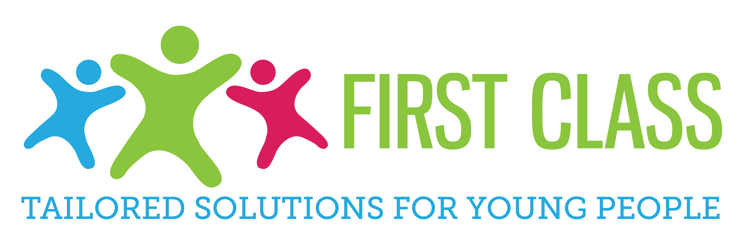

Equality and Diversity Policy

February 2015

EQUALITY INFORMATION STATEMENT

The Equality Act 2010 introduced a single Public Sector Equality Duty (PSED). The duty replaced previous equality duties on race, disability and gender. In summary, the duty requires public bodies, which includes schools and Pupil Referral Units to have ‘due regard’ to the need to:
- eliminate unlawful harassment, discrimination and victimisation
- advance equality of opportunity
- foster good relations

The Directors at First Class Tailored Solutions are required to publish information to show that its members have consciously thought about the three aims of the Equality Duty as part of the process of decision-making. The information must include evidence of how the service impacts on people who share a relevant protected characteristic. The protected characteristics are:-
- race
- disability
- gender
- age
- religion or belief
- sexual orientation
- pregnancy and maternity
- gender reassignment
- marriage and civil partnership
The following statement has been approved by the leadership of FCTS.

STATEMENT OF EQUALITY INFORMATION

FCTS provides out of school provision for children and young people aged between 7-18 years who are currently not in other schools for part of the weekly timetable. Whilst children and young people are being taught by FCTS staff ,FCTS is committed to ensuring they have access to an appropriate curriculum leading to exciting and challenging learning opportunities which help them to achieve their potential. The provision delivered by FCTS supports all learners to acquire essential skills needed to return successfully to a mainstream setting and/or appropriate alternative provision.

The relevant protected characteristics considered in the planning, provision and policies at FCTS are race, disability, gender, age, religion or belief. FCTS addresses these issues as follows:

Race, religion and belief
FCTS monitors the ethnic make-up of its population continually, ensuring that the cultural and religious needs of its learners are appropriately embraced in all aspects by tutors delivering education on behalf of FCTS.

All staff have a good understanding of the religious, race and cultural differences of the children and young people we serve and they work hard to secure and maintain mutual understanding and respect. As best practice, FCTS is robust in responding to and recording racial incidents and uses education to improve tolerance and understanding through its personalised curriculum.
Promoting fundamental British Values

Staff have an obligation, as part of a broad and balanced curriculum, to promote the spiritual, moral, cultural, mental and physical development of learners. Within this remit, staff should also promote the fundamental British values of democracy, the rule of law, individual liberty, and mutual respect and tolerance of those with different faiths and beliefs. Actively promoting the values means challenging opinions or behaviours that are contrary to British values.
The list below describes the understanding and knowledge expected of learners as a result of promoting fundamental British values.
- An understanding of how citizens can influence decision-making through the democratic process.
- An appreciation that living under the rule of law protects individual citizens and is essential for their well-being and safety.
- An understanding that there is a separation of power between the executive and the judiciary, and that while some public bodies such as the police and the army are held to account through Parliament, others such as the courts maintain independence.
- An understanding that the freedom to choose and hold other faiths and beliefs is protected in law.
- An acceptance of the importance of identifying and combating discrimination.

Disability and Gender

A proportion of staff have undergone specialist training in disability and accessed a range of courses in Special Educational Needs (SEN). Every child has a personalised curriculum that takes into account their individual needs and barriers to learning. Each personalised education programme evidences that reasonable adjustments are made to the curriculum, social activities and environment.

Equality Objective 2013/14
In partnership with locality schools, FCTS will enable young people to be socially included within their community by securing a timely supported re-integration into an appropriate school for as many young people as possible.
Triple Crown Centre
Complaints / Incidents
FCTS has not received any complaints in the previous twelve months with regard to equality. No incidents involving racial discrimination have been recorded during the same period.

Date - February 2014
Updated Feb 2015 B Kirk

